CHART Intranet Mapping Application
Users’ Manual

For:

Coordinated Highways Action Response Team (CHART)


State Operations Center
Hanover Complex
7491 Connelley Drive
Hanover, MD 21076-1701

In Response to:
Contract DBM-2027-TSP
Requisition # J01R3200010

By:



November 5, 2003

Revision History

Date | Doc. Version | Description
November 5, 2003 | 1.0 | Initial Version

Table of Contents

1. Overview 4
2. Screen Layout 4
3. Basic Map Navigation 6
4. Advanced Map Navigation 7
5. Controlling Layer Visibility 7
6. Using Locator 9
7. Viewing Event List 13
8. Locating Event 16
9. Locating Road Closure 18
10. Other Tools 20

Overview
This document serves as CHART Intranet Mapping Application’s Users’ Manual. Given that the application is quite interactive, this document starts by explaining the overall user interface (UI). It then instructs how to perform specific tasks using the application.

Screen Layout
The application interface includes following major frames.

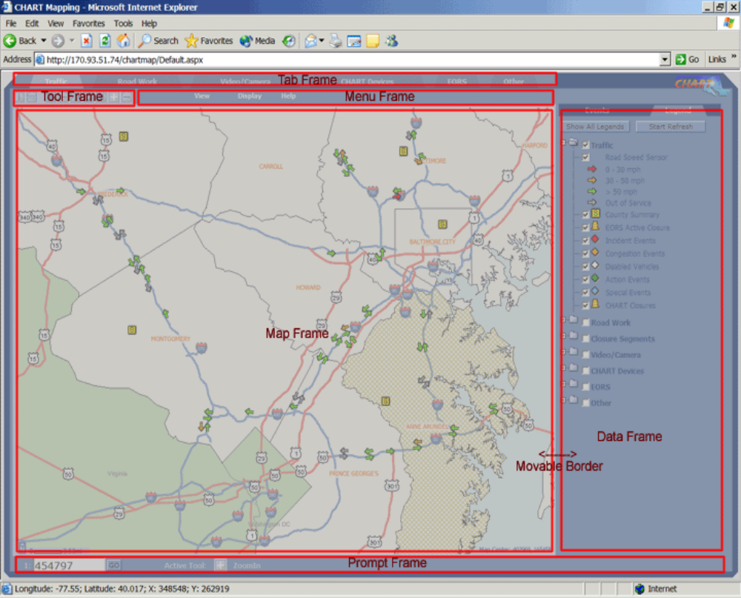

1. The Tab Frame hosts a set of tabs. Each tab corresponds to a theme that groups multiple map layers. The tabs are:

2. The Tool Frame hosts a toolbar. The toolbar includes following buttons in order they are displayed:

Identify, Measure Distance, Zoom to Full Extent, Zoom to Previous Extent, Pan, Refresh, Clear Markup, Zoom in, Zoom out.

If user moves mouse cursor over the button, the tip of the button will display.

3. The Menu Frame hosts the menu system.

The “View” menu allows user to zoom map to several sets of predefined map extents: region, county, district, and operation center.

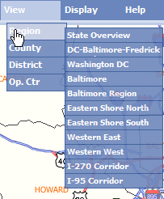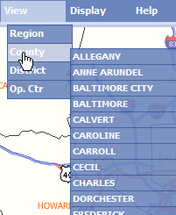

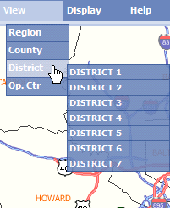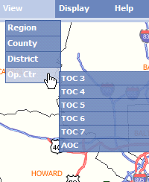

The “Display” menu allows user to go to a few special pages.

- Selecting “Login to CHART” will display the login page in the full browser window.
- Selecting “Event List” will display event list page in Data Frame.
- Selecting “Legend” will display map legend page in Data Frame.
- Selecting “Locator” will display route locator page in Data Frame.

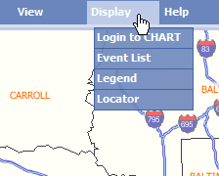

The “Help” menu allows user to open the Users’ Manual page in a separate browser window.

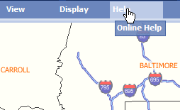

4. The Map Frame displays map.

5. The Data Frame may display one of the following: map legend, event list, event detail, Log In page, road closure detail, or locator.

6. The Prompt Frame displays map scale, active tool, and when measuring tool is used, results of distance measuring.

The border between the Map Frame and the Data Frame is movable (horizontally), allowing user to define proper map size. When Map Frame or Internet Explorer window is resized, map image will fit in the full Map Frame at next map action.

Basic Map Navigation
Basic map navigation includes common zooming and panning functions, refreshing, and map markup clearing. User performs basic map navigation through the toolbar.

Zooming to Full Extent
Clicking on the button will zoom map to the full extent.

Zooming to Previous Extent
Clicking on the button will zoom map to the previous extent. When there is no previous extent, map stays at current extent.

Panning
To pan to a new location, user first clicks on the button. Then, to center at a desired location, user can click on the location to move to on the map. Alternatively, user can click and drag the mouse, and then release it at a desired location.

Refreshing Map
Clicking on the button will refresh the map.

Clearing Markup
When locating event or closure, a route might be highlighted and/or its mile point be labeled. To clear these markups, user clicks on the button.
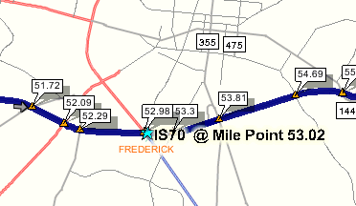 -> 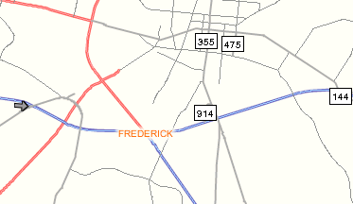

Zooming In
To zoom in to map, user first clicks on the button. Then, user either clicks on the desired location on map to use default zoom scale, or drags a rectangle and then releases mouse to zoom to the rectangle area.

Zooming Out
To zoom out, user first clicks on the button. Then, user clicks on a location on map. Map will zoom out by default factor and center at the clicked location.

Advanced Map Navigation

Zooming to Scale
To zoom map to a specific scale, user enters a positive number in the text field on Prompt Frame, and then clicks on the “Go” button. Map will center at current map center.

Zooming to Predefined Map Extent
To zoom to predefined map extent, user first selects “View” menu in Menu Frame. User then selects a view type of “Region”, “County”, “District”, or “Op. Ctr”. From the available view extents under selected view type, user selects the one to zoom to.

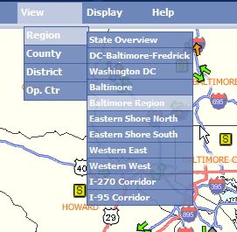

Zooming Using Coordinate Locator
See Section 6.4.

Controlling Layer Visibility
Layers are grouped into themes. Layer visibility can be controlled individually, or by the theme as a whole.

Controlling Layer Visibility Using Theme Tabs
When clicking on a theme tab, all layers under the theme will be turned on (unless otherwise configured), and all layers not under the theme will be turned off.

Controlling Layer Visibility Using Legend Panel

Legend Panel Layout
Legend panel shows all themes and layers in a tree structure. Each theme can be expanded by clicking on icon to the left of the theme label, or be collapsed by clicking on icon to the left of the theme label.

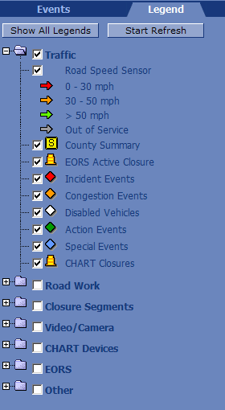

To expand all theme nodes, user can click on the “Show All Legends” button. Once it’s clicked, the button caption will change to “Hide All Legends”. Clicking on “Hide All Legends” button will collapse all theme nodes.

Turning On and Turning Off Theme
To turn on all layers under a theme, user can check the checkbox to the left of the theme label. To turn off all layers under a theme, user can uncheck the checkbox to the left of the theme label.

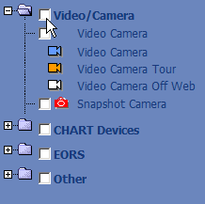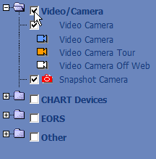

Turning on and Turning off Layer
To turn on or turn off individual layers, user first expands the theme node. To turn on the layer, user checks the checkbox to the left of the layer labe. To turn off the layer, user unchecks the checkbox.

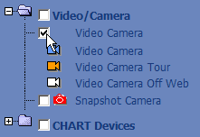

Using Locator

Locator Layout
Locator page contains three tabs. Clicking on each tab will display a specific type of locator.

By default, “Route” tab is selected and route locator is displayed. Clicking on “Landmark” tab will display landmark locator. Clicking on “Coordinate” tab will display a locator using coordinates.

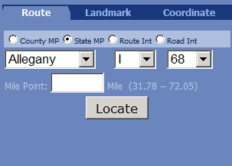

Landmark Locator
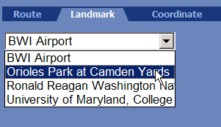

Landmark locator lists all landmark records. To locate a landmark, user first selects the landmark form the list, and then clicks on “Locate” button. Map will center on the landmark. If the landmark layer is not turned on, it will be turned on.

Coordinate Locator
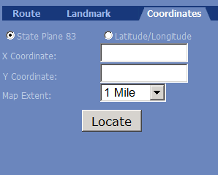

Coordinate locator allows user to locate an area by specifying the area center and area extent width. To do so, user first chooses the coordinate system as Maryland State coordinates or latitude and longitude coordinates. User then fills in the x and y coordinates in according text fields. User should also choose map extent width from the dropdown list. At last, user clicks on the “Locate” button. Map will center on the specified coordinates. Landmark layer will be turned on if it’s not turned on yet.

Using Route Locator
Route locator supports four locating methods. User can locate state mile point, locate county mile point, locate a route intersection, or locate a road intersection. To select a locating method, user checks the according radio button.
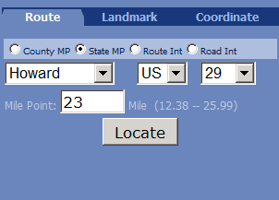

Locating State Mile Point
To locate, user first selects a county, then selects the route type, then selects the route number. After all these selections, the minimum mile point value and maximum mile point value for the route will be displayed.

User then fills in the desired mile point and then clicks on “Locate” button. If no value is entered, application will use the average of the minimum and maximum values as the user input.

When mile point is located, the map will zoom to the entered mile point. The route is highlighted, mile points on the route labeled, and a star displayed at the mile point location.
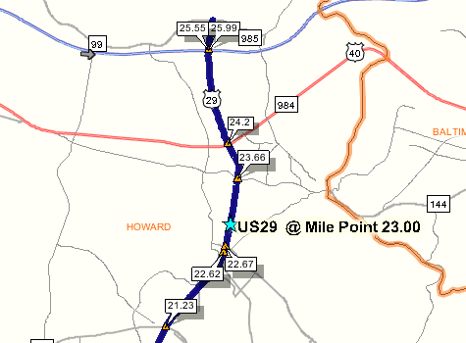

If user has input a state mile point that is not valid for the county, application will try to locate the mile point throughout the whole route. If this fails, user will receive feedback.

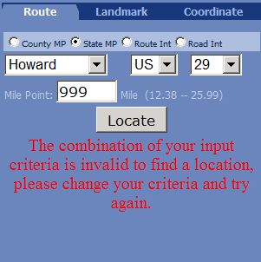

Locating County Mile Point
Locating county mile point follows the same procedures as locating state mile point. However, there is an important difference. If user input a mile point that is not valid for the county, application will not try to locate the mile pint throughout the whole route. Instead, user will receive feedback.

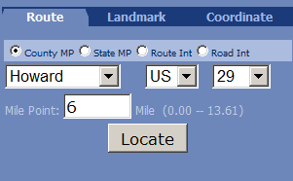

Locating Route Intersection
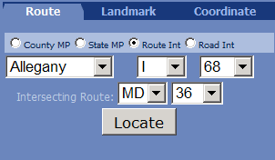

To locate, user first selects a county, then selects the route type, then selects the route number. After all these selections, the intersecting routes’ type and number will be displayed. User selects the route type and route number, and then clicks on the “Locate” button to locate the intersection.

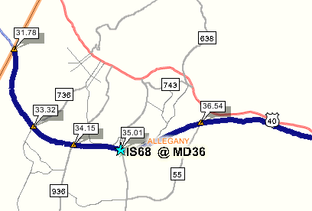

When an intersection is located, the map will zoom to the intersection. The first route is highlighted with mile points labeled, and a star is displayed at the intersection location.

Locating Road Intersection
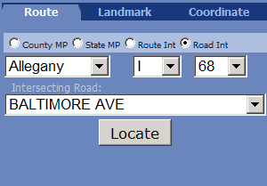

To locate, user first selects a county, then selects the route type, and then selects the route number. After all these selections, the intersecting roads with the selected route will be displayed. User selects a road, and then clicks on the “Locate” button.

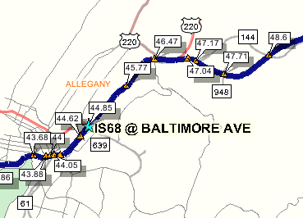

When an intersection is located, the map will zoom to the intersection. The first route is highlighted with mile points on labeled, and a star is displayed at the intersection location.

Viewing Event List

Event List Layout
Event list includes following components:

1. Event Records
Event records are displayed in a list. Mapped event record has a lighter background; unmapped event record has a darker background.

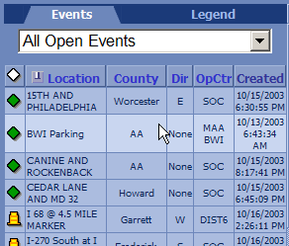

2. Table Header
Table header lists the field names for event records.

3. Filter Criteria
Filter section allows user to filter the event list.

4. Popup Menu
When user selects an event record, and right clicks mouse, a pop up menu displays. The menu items allows user to perform functions such as reviewing details of the event or locating event.

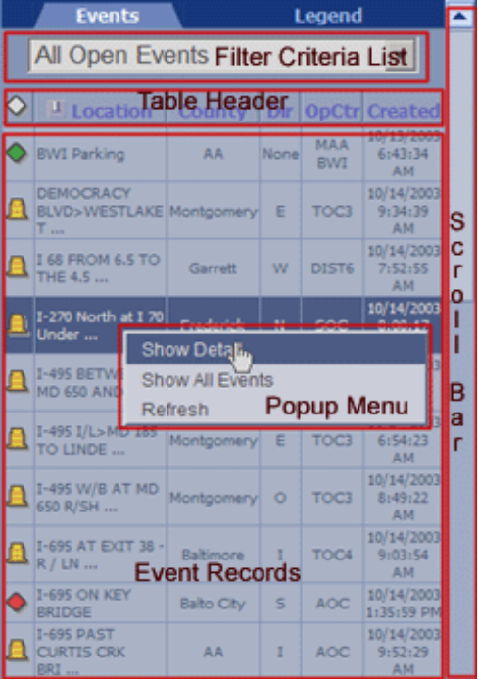

Sorting Events
Event list can be sorted by following fields: event type, mapped or not, location, county, direction, operation center, and time created.

Clicking on each column header will sort the events by that field; clicking the “push pin” icon to the left of “Location” column header will sort the events by whether an event has been mapped; clicking on the “diamond” icon will sort the events by event type.

Clicking on the header again will reverse sort direction.

Filtering Events
By default, the event list displays all open events. User can choose to display events based on certain filtering criteria. To do so, user selects the filtering criteria from the dropdown list.

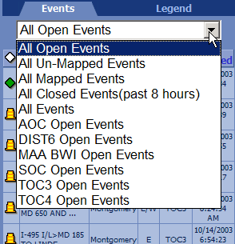

Refreshing Event Automatically
Event list is configured to automatically refresh at 30 second interval.

Popup Menu Items
Popup menu on Event List page has following items:

“Center On it”
This menu item is available if user selects an event that has been mapped. Selecting this item will make the map center on the event location.

“Show Detail”
Selecting this item will make Data Frame to switch to Event Detail page for the selected event.

“Show All Events”
Selecting this item will display all events. This is equivalent to selecting “All Events” from the filtering criteria list.

“Refresh”
Selecting this item will force immediate refresh of event list.

“Map Event” and “Edit Location”
Both “Map Event” and “Edit Location” menu items are available for CHART user only. If the selected event has not been unmapped yet, the “Map Event” menu item will display. Otherwise, the “Edit Location” menu item will display. Selecting either menu item will cause Data Frame to display Event Detail page for locating event.

Locating Event
To locate events, Data Frame should be displaying Event Detail page. Only CHART user with traffic event managing right can locate events. Other users may view event details, but the editing buttons are hidden.

Logging to CHART
To login to CHART, user selects “View” menu from Menu Frame, then selects “Login to CHART” menu item. The login page will display in the full browser window.

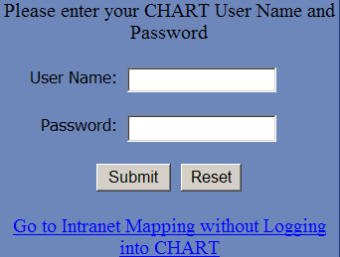

User must login with a valid CHART user name and password with traffic event managing right.

Event Detail Page Layout

Event Detail page has three parts:

1. Event Details
Event details are displayed in a table.

2. Action Buttons
Which buttons are available depend on the user type, and whether the event is mapped. The possible buttons are:
- “Map Event”: for CHART user, with unmapped event
- “Edit Location”: for CHART user, with mapped event
- “Unmap Event”: for CHART user, with mapped event
- “Highlight Event”: for any user, with mapped event
- “Center on Event”: for any user, with mapped event
- “Back to Event List”: for any user, with any event

3. Locator
The locator resides at the lower part of the Data Frame. See Section 6 on how to use locator.

In following screenshot, the event has not been mapped. Only two action buttons are displayed.
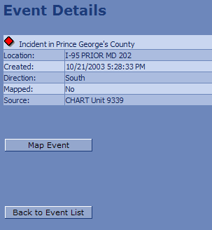

In following screenshot, the event has been mapped. Five action buttons are displayed.

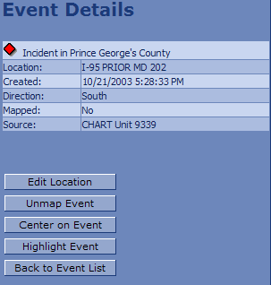

Auto-Locate Event Based on Event Location from CHART
The mapping application makes an attempt to parse the event location information and automatically locate the event. So inputting a valid location information in the CHART application will make locating the event much easier. The parser tries to find route numbers, mile points, exit numbers and intersection route information. If the parser finds a match, it will automatically center on the location, otherwise, it will try to zoom to the county of the event (if specified).

The parser is not case-sensitive and will ignore space characters like -, space, @, etc. So, IS 95 and is-95 or IS95 are the same to the parser.

The parser recognizes the following patterns:

- IS or I followed by a number – Interstate route
- MD followed by a number – Maryland route
- US followed by a number – US route
- MP or MM followed by a number – Mile point value
- Exit or Ex followed by a number – Exit number

The following are the cases that the mapping application can handle:
- Route and Mile Point
US-50 @ MP 20
IS-95 @ MP 38
MD 210 @ MP 10
- Route and Exit Number
US 50 exit 20
IS 95 exit 38
MD 210 exit 10
- Route intersection
US 50 south bound @ MD 210
IS 95 and MD 32

Mapping Event and Edit Event Location (CHART User Only)
To map an unmapped event, user clicks on the “Map Event” button. To edit location of event that has been mapped, user clicks on “Edit Location”.

After clicking on the desired location, a red cross will display at the location, and system will request user confirmation. Once the event has been mapped, map will refresh.

Unmapping Event (CHART User Only)
In rare occasions when en event need to be removed from map, user clicks on the “Unmap Event” button. System will request user confirmation.

Centering on Event (Mapped Event Only)
This functionality is available to mapped events only. To do so, user clicks on “Center On Event” button, and the map will center on the event location.

Highlighting Event (Mapped Event Only)
This functionality is available to mapped events only. To do so, click on “Highlight Event” button, then the event icon on map will blink four times.

Going to Event List Page
User can click on “Back to Event List” button to return to Event List page.

Locating Road Closure
User locates road closure in road closure detail page. When Data Frame shows this page, the map should highlight the road to close, and label the mile points on the road.

Road Closure Detail Page Layout
Road Closure Detail page has following components:

1. Road Closure Details
Closure details are displayed in a table.

2. User Input Area
User input area lists the steps for locating a closure, and displays text fields and buttons.

3. Locator
The locator resides at the lower part of the Data Frame. See Section 6 on how to use locator.

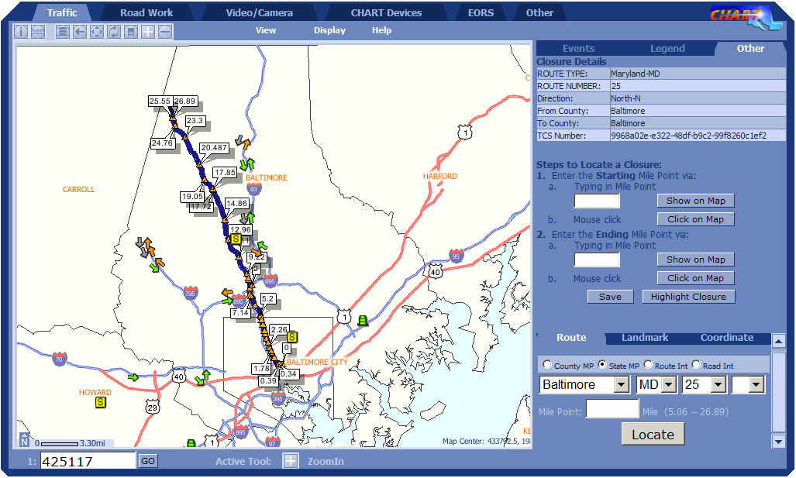

Specifying Closure Starting Point And Ending Point
The system requires user to specify both starting and ending points for road closure.
To specify starting point, user uses the following action buttons and text fields.

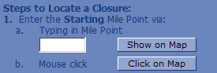

To specify ending point, user uses the following action buttons and text fields:
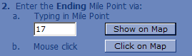

The steps for specifying either starting or ending point are:
a. Fill in a mile point in the text field, and then click on “Show on Map” button. If the input value is valid, a pink cross should display on the map at the specified road mile point. If the input is not valid, user will be reminded by a message box.

b. Click on “Click on Map” button, and then click at the desired location on the road. A pink cross should display at the clicked location, and the text field displays the mile point value.

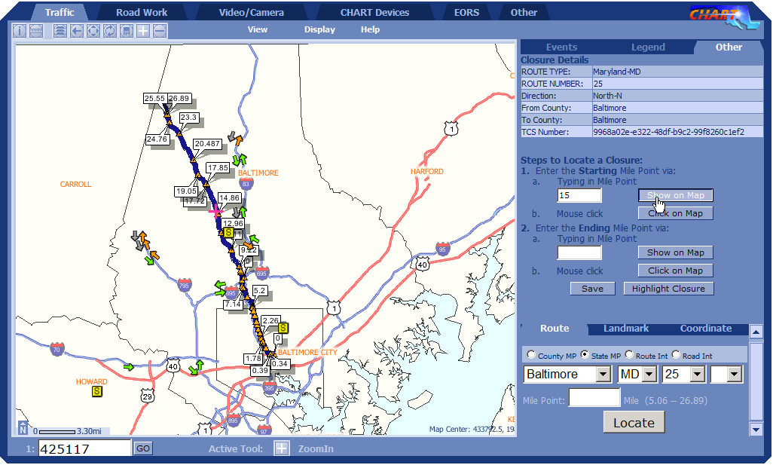

Using Same Point for Starting Point and Ending Point
If the road closure applies to one point rather than a segment, user can fill in the same mile point value as in starting the start mile point field.

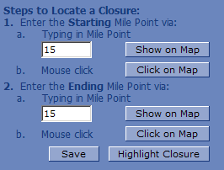

Saving Location
After both starting and ending points are specified, user clicks “Save” button to save the location information into database. Map will refresh with newly added closure starting point, and browser will return to EORS permit list page.

Highlighting Closure
If closure has already been mapped, clicking on “Highlight Closure” button will cause the closure start point icon to blink four times.

Other Tools

Viewing RWIS Site Links
To show RWIS site links, user clicks on the RWIS icon on map. The site links page will be displayed in Data Frame.
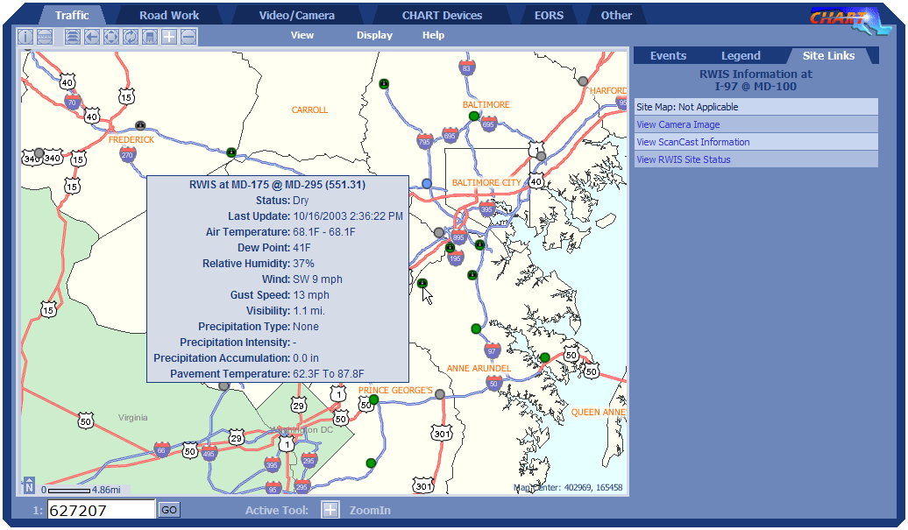

The site links page will display the RWIS location information, and provide following links, if applicable.
- Site Map: this links to the RWIS site map, to be discussed in Section 12.
- Camera Image: this links to the image page for the RWIS, from “Scan Web” web site.
- Scancast Information: this links to scancast information page from “Scancast” web site.
- RWIS Site Status: this links to RWIS site status page from “Scan Web” web site.

Some links may not apply to a RWIS site. In this case, the link should read “Not Applicable”. In the screenshot below, camera image and scancast information links do not apply to this RWIS.

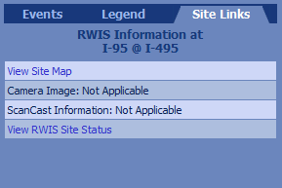

Viewing RWIS Site Map
RWIS site map displays the aerial photo of the site location, and shows the tower and RWIS sensors. The tower is displayed as red triangle, and sensors displayed as circles color-coded depending on sensor status.
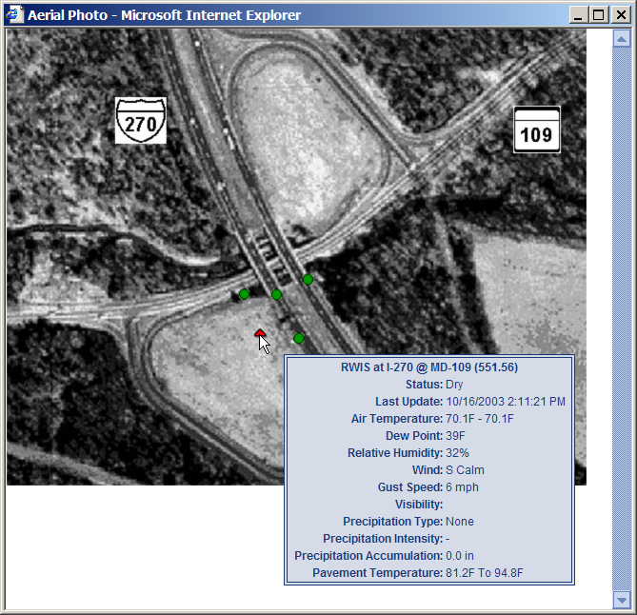

When user moves mouse cursor over tower or sensor icon, a tooltip will display detailed information

Showing Location Coordinates
If user moves mouse cursor over the map, the state coordinates and geographic coordinates of that location will display in Internet Explorer status bar.

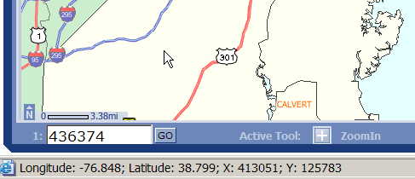

Identifying Road
To identify a road, user first clicks on the button on toolbar, then clicks on the road. A message box will display with the identify result. The result should include following information: route type, route number, road name, state mile point, and number of total lanes.

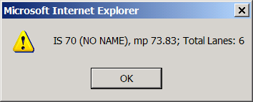

Identifying Winter Storm Segments
Winter storm segment layer must be turned on before user can identify WSMS segments.
To identify, user first clicks on the button from on, and then clicks on the segment. A message box will display with the identify result for road segments on both directions. The result should include following information: route type, route number, direction, condition code, condition text, and last updated time.

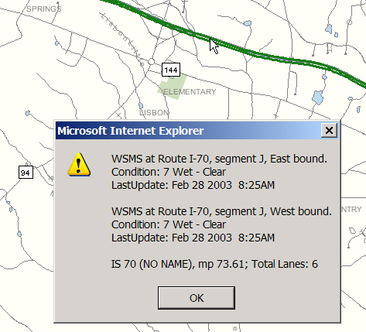

Note the clicked road information will also display.

Identifying Event and Devices
Events and devices are identified through tooltip on map. If user moves mouse cursor over the event or device, a tooltip will display displaying the event or device information. Moving the mouse cursor away will hide the tooltip.

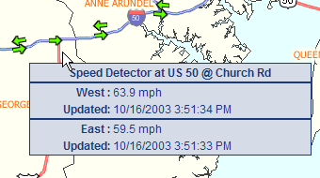

Measuring Distance
To measure distance on map, user first clicks on the button on toolbar. User then clicks on the start point and the end point.

User can continue to click on map, and new segment will form a polyline. The total distance of segments will be displayed on the Prompt Frame.

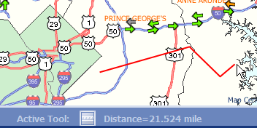

Clicking on button again will clear current measurement and initiate for a new measurement. To exit measuring mode, user simply clicks on any other button on toolbar. The segments will disappear from map.

Refreshing Map Layers Automatically

To start automatic refreshing at configured interval, user clicks on the “Start Refresh” button on legend panel. The button caption will change to “Stop Refresh”. To stop automatic refreshing, user clicks on the “Stop Refresh” button.

